PARAKUIHI | BREAKFAST
"Don’t worry, we’ve got your breakfast until 2 pm"

HĒKI KAURORI | EGGS BENEDICT
Smoked Hāngī Hash, Potato, Pumpkin, Kumara,
Two Poached Eggs, Hollandaise…
-Eggs Māori: Aoraki Hot Smoked Salmon (GF) 27
-Eggs Pacifica: Palusami, Corned Beef Crumb (GF) 26

-Eggs Kiwi: Free-range Bacon (GF) 25
-Eggs Florentine: Spinach (GF) 24

PĀKĀ PARAKUIHI | BREAKFAST BURGER (GFA) 26
Bacon, Egg, Pork & Watercress Sausage on Rēwana Bun,
Watercress Pesto, Hollandaise
KARAKIA KAI
In Māori culture, acknowledging the significance of food through giving thanks, reflects a deep respect for the land, nature, and the connections between people and their sustenance.

RAHOPŪRU | SMASHED AVOCADO (GFA, VGN) 27
Smashed Avocado, Rēwana Bread, Pickled Fennel,
Cherry Tomatoes, Olives, Sliced Radish & Coriander

KĀNGA KŌNATUNATU | FRITTER (GF, VGN) 27
Smoked Tomato, Corn, Kūmara & Carrot Fritter, Avocado Salsa,
Vegan Sour Cream Non-Vegan, add-on Free Range Bacon 9

TĪHI PARAI | HALOUMI, VEG (VEG, GF) 27
Zany Zeus Haloumi, Honey Roasted Beetroot, Baby Carrot,
Lemon & Horopito Pickled Fennel, Smoked Pumpkin Puree,
Fried Egg

TŌHI WĪWĪ | KARAKA TOAST (VGT, GFA) 27
French Toasted Rēwana, Grilled Banana,
Butterscotch Mascarpone, Caramel Sauce

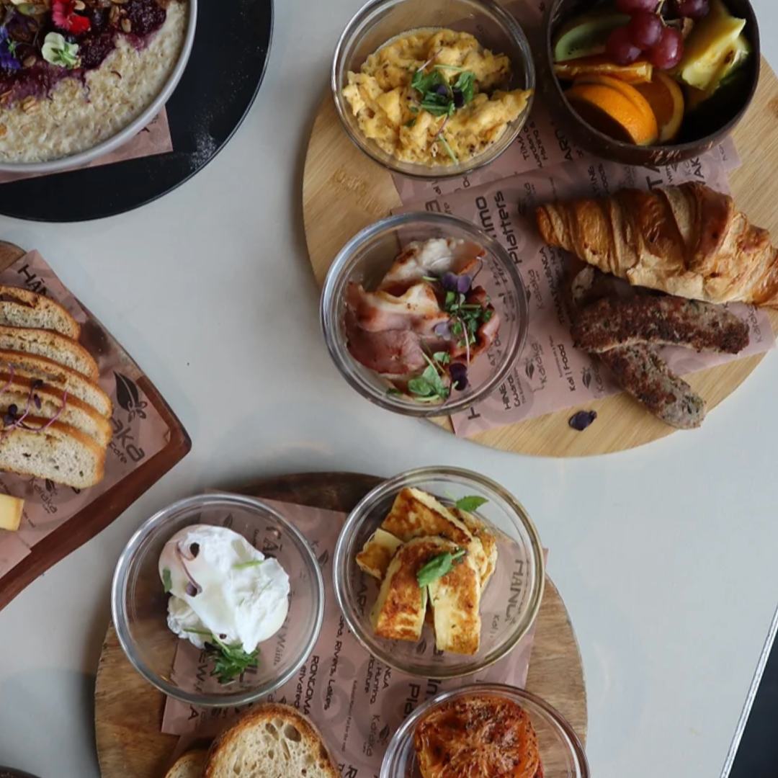

Egg (gf, df) 3.50
Mushroom, Grilled (vgn, gf) 7
Bacon (gf, df) 9
Spinach, Wilted (gf, df) 6
Hāngī Hash (gf, df) 8
Smoked Tomato (gf, df) 7
Haloumi (gf, df) 8
Smoked Salmon (gf, df) 9
PERETI PARAKUIHI | BREAKFAST BOARD
Please choose your favourite items and we will create a breakfast board
Spiced Beans (gf, df) 6
Fresh Fruit (gf, df, vgn) 6
Croissant (warmed) 5
Palusami 6
French Toast 10
Hollandaise 3
Fry Bread (1) 7
Avocado, Smashed (gf, df, vgn) 6
Pork & Watercress Sausage 5
Sour Dough Toast (gfa) 4
Gluten Free Toast 4
Rēwena Toast 4

